Anthony Redamonti

Syracuse university

Lab 6

CSE-644 Internet security

Dr. Syed shazli

3/8/2023

Task 1: Becoming a Certificate Authority (CA)

**Part 1: The Configuration File**

The commands below were used to create a copy of the configuration file “openssl.cnf” along with several sub-directories in the demoCA directory.

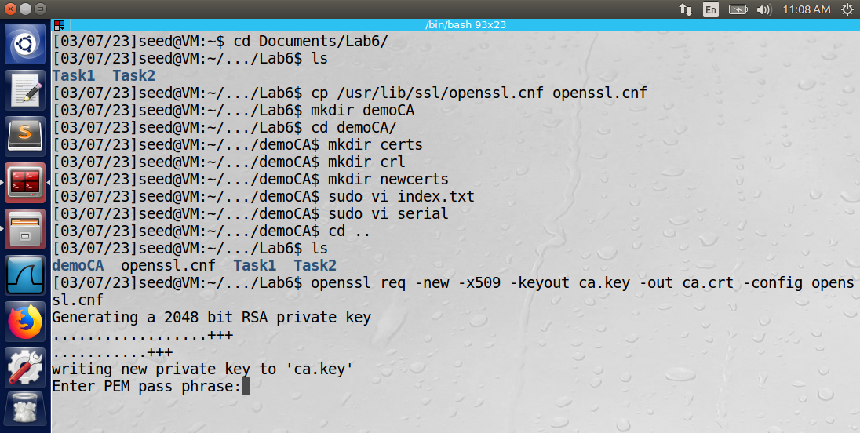

**Part 2: Certificate Authority**

The command below was used to generate a self-signed certificate for the certificate authority. After generating this certificate, the CA will act as the root CA.



The information below was entered for the root CA. The common name was “AnthonyRedamonti”.

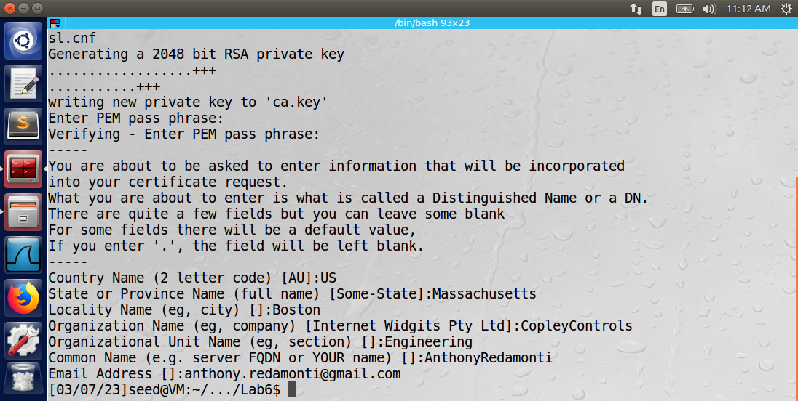

Observation: After executing the commands, the root CA’s private key (ca.key) and certificate (ca.crt) were generated.

Explanation: The root CA will be used in future sections to generate certificates for other servers.

Task 2: Creating a Certificate for SEEDPKILab2020.com

**Part 1: Generate public/private key pair**

The following command was used to generate the public/private key pair for the SEEDPKILab2020.com server.

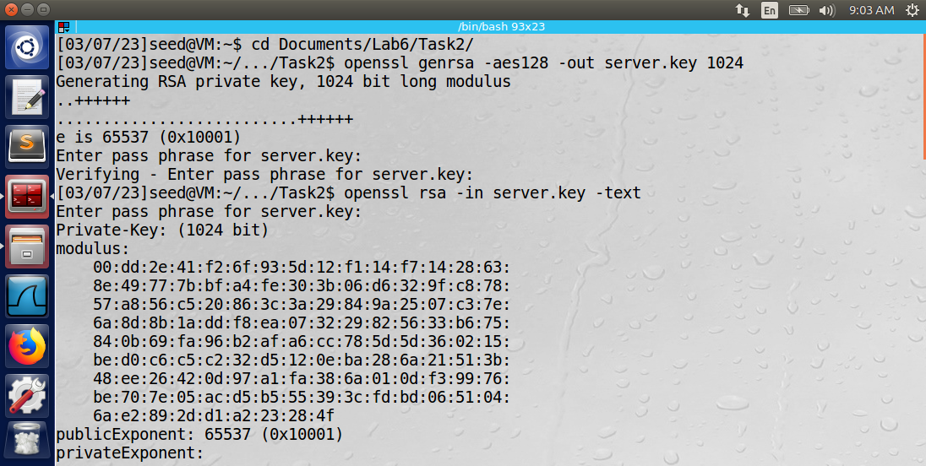

**Part 2: Generate a Certificate Signing Request (CSR)**

The following command was used to generate a certificate signing request (CSR) for the SEEDPKILab2020.com server. Note the Common Name was “SEEDPKILab2020.com”.

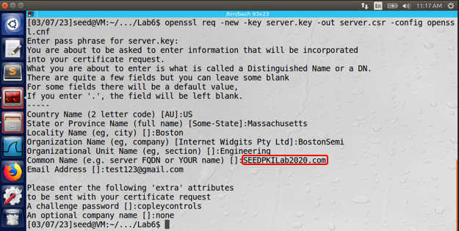

**Part 3: Generating Certificates**

The following command was used to generate a certificate for the SEEDPKILab2020.com server. Note the error returned “The organizationName field needed to be the same in the CA certificate (CopleyControls) and the request (BostonSemi).”

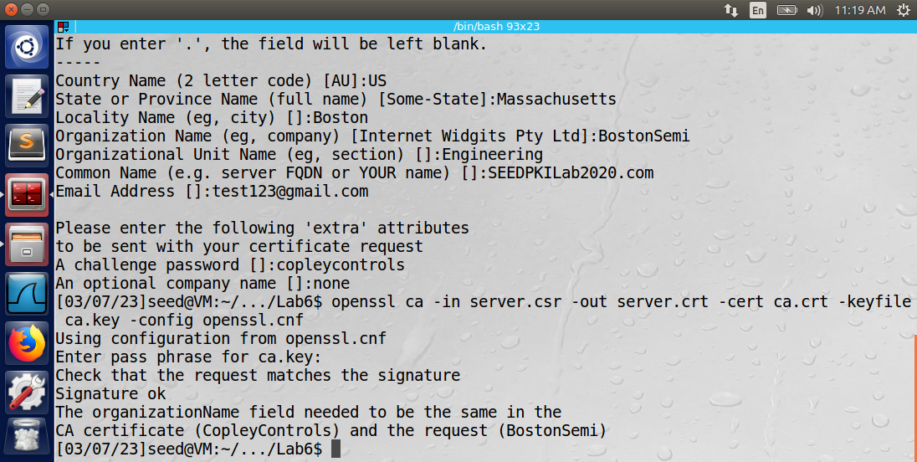

To ignore this error, the policy in the configuration file (openssl.cnf) was changed to “policy_anything”.

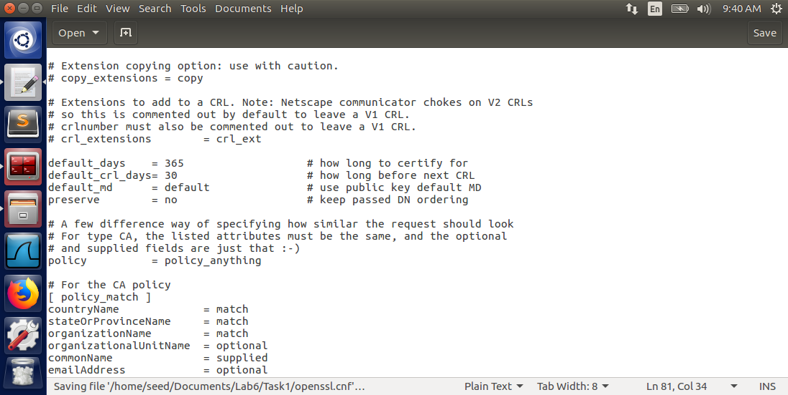

The previous command to generate the certificate was rerun and successfully completed.

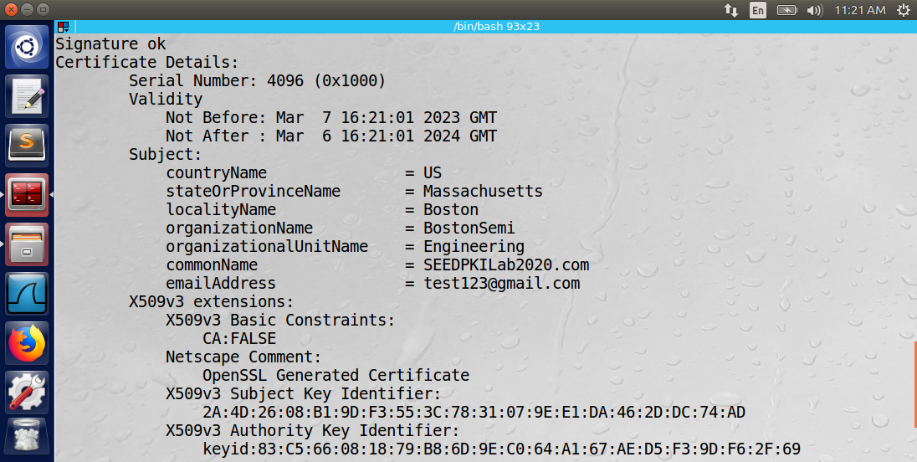

Observation: After executing the commands, the public/private key pair were generated for the SEEDPKILab2020.com server. The certificate signing request was generated and the root CA signed it and generated the certificate for SEEDPKILab2020.com.

Explanation: The SEEDPKILab2020.com server owned a certificate after all these commands were executed. The certificate was then ready for deployment.

Task 3: Deploying Certificate in an HTTPS Web Server

**Part 1: Configuring DNS**

The following entry was added to the IPv6 capable hosts list in the /etc/hosts file. Notice how the IP address is shared between the SEEDPKILab2020.com domain and the localhost domain.

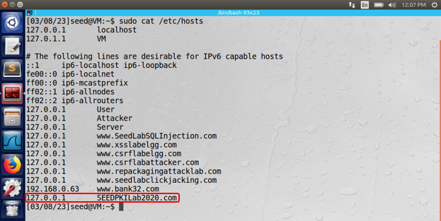

**Part 2: Configuring the web server**

The following commands were used to launch the web server using the previously generated certificate.

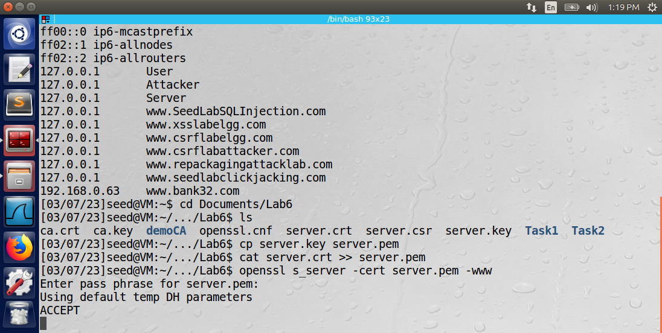

The openssl tool launched the web server using the s_server command.

**Part 3: Getting the browser to accept our CA certificate**

The ca.crt (self-signed root certificate) was added to the trusted authorities section of the Firefox browser settings shown below.

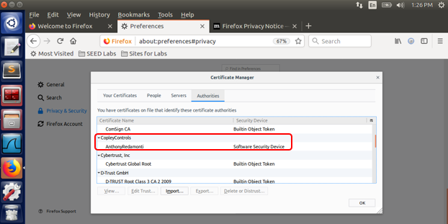

The “Trust this CA to identify web sites” checkbox was checked.

**Part 4: Testing the HTTPS website**

After adding the CA root certificate to the browser’s list of trusted authorities, the SEEDPKILab2020.com server was reachable from the Firefox browser. Note: the openssl tool was still hosting the web server during this test.

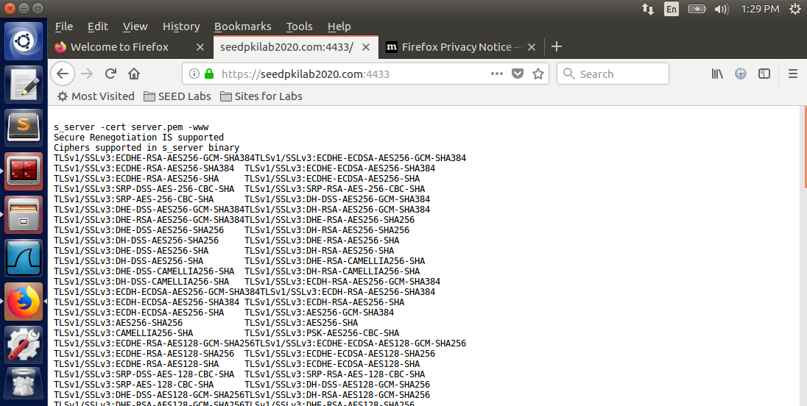

The bless hex editor tool was then used to edit one byte of the server.pem file, and the openssl tool relaunched the web server.

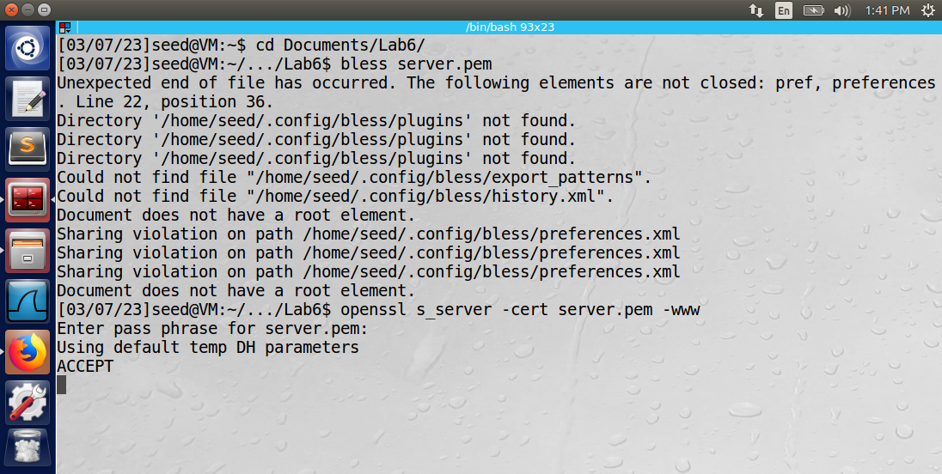

The connection to the SEEDPKILab2020.com server failed. The certificate was identified as invalid.

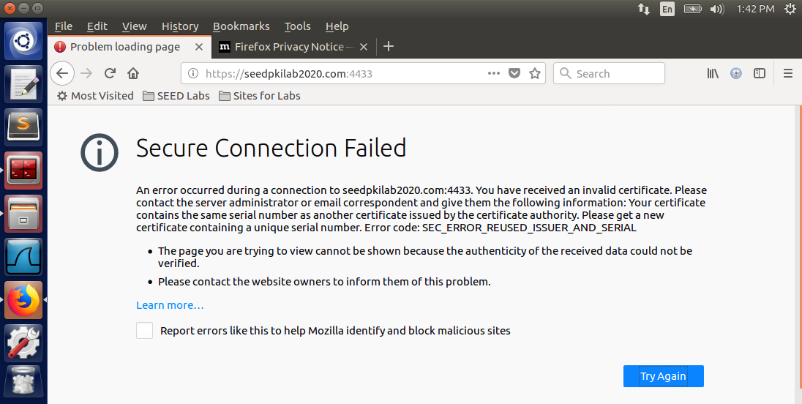

Next, the certificate was restored to its original condition and a localhost connection was attempted, since the localhost and SEEDPKILab2020.com server share the same IP address (127.0.0.1).

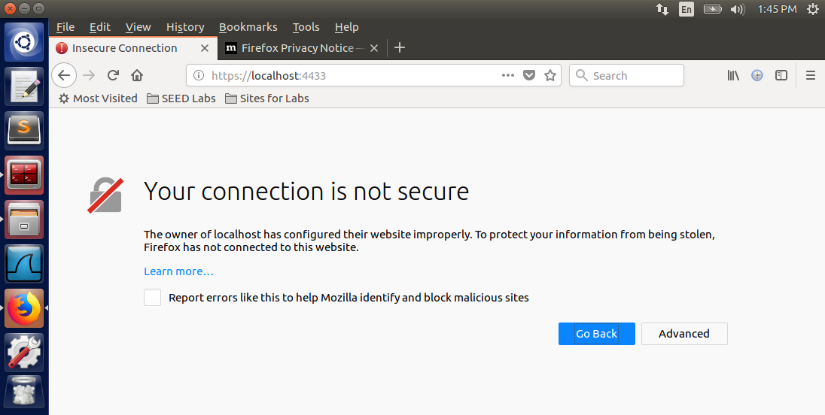

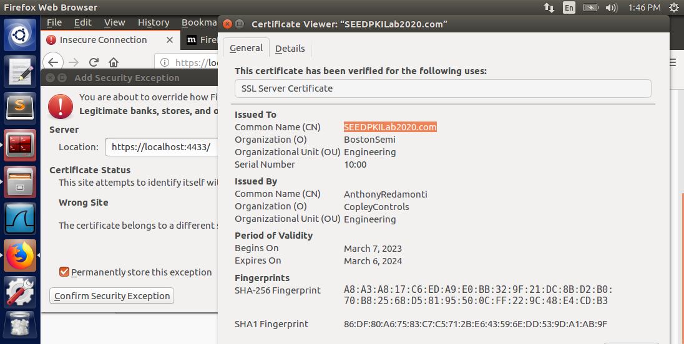

The connection to localhost:4433 failed because the certificate was identified as belonging to a different server (Common Name: SEEDPKILab2020.com). If the “Confirm Security Exception” button is pressed, the security exception is added to the browser, and the localhost::4433 domain can use the certificate and connect to the SEEDPKILab2020.com web server.

Observation: The openssl tool was used to launch the web server SEEDPKILab2020.com. If the certificate has been modified, it will be considered invalid. If the domain name conflicts with the IP address in the local DNS, the connection will not be considered secure.

Explanation: The security measures ensure that an attacker can’t modify certificates belonging to other servers and that the domain name/ip address pair is valid.

Task 4: Deploying Certificate in an Apache-Based HTTPS Website

The certificate and key from the previous task were copied and renamed as SEEDPKILab2020_cert.pem and SEEDPKILab2020_key.pem using the commands below.

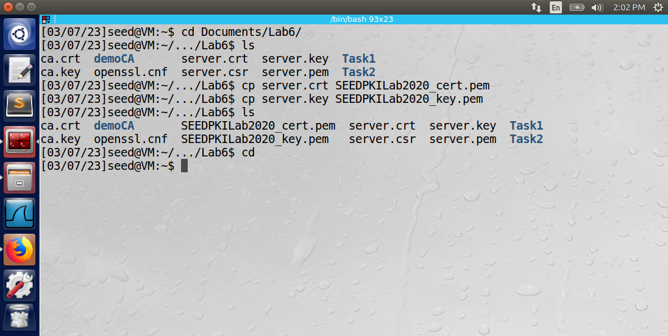

The following VirtualHost entry was added to the /etc/apache2/sites-available/default-ssl.conf file. Notice the file paths to the newly created pem files.

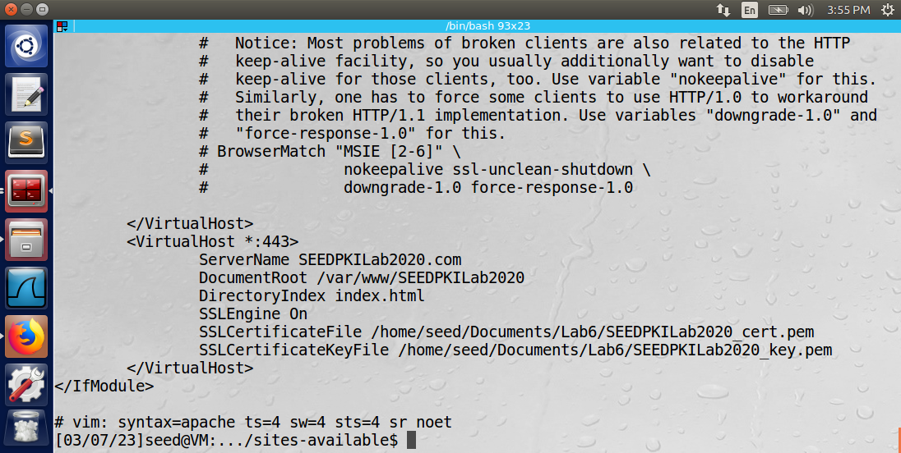

Next, the SEEDPKILab2020 directory was created in /var/www/. Then the index.html file was created using the commands shown below.

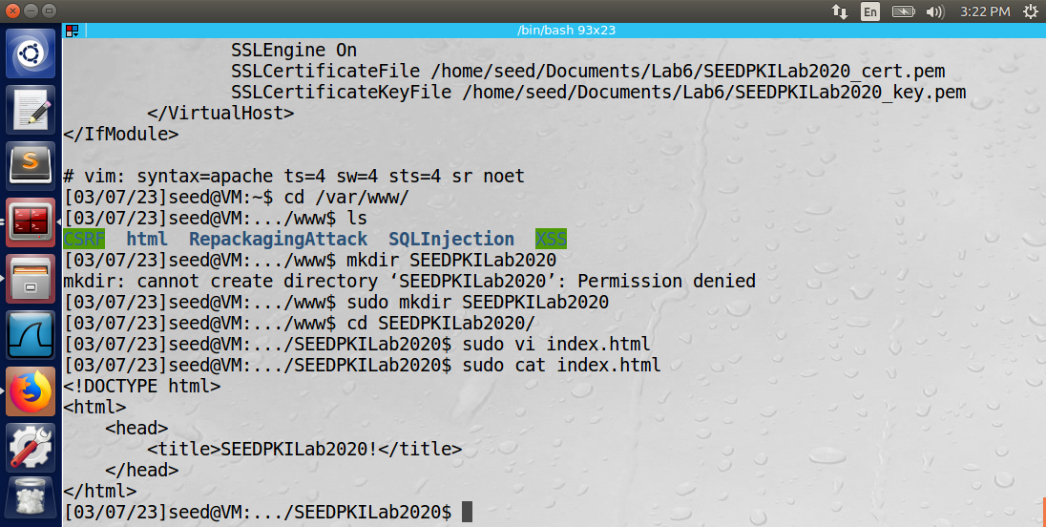

The apache2 configuration file was then tested for errors using the command below.

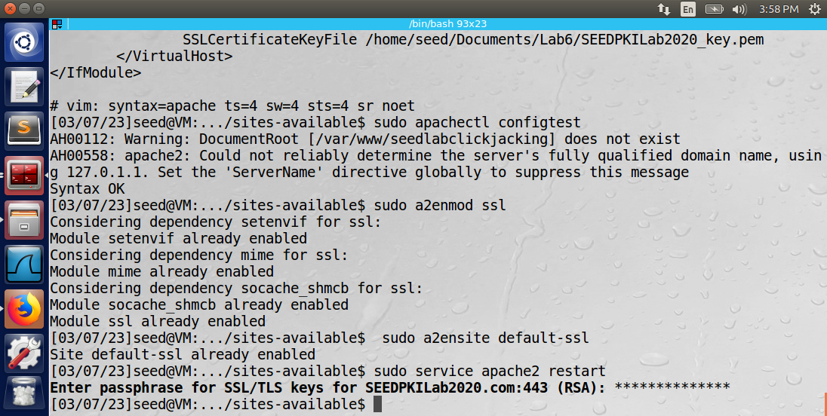

The SSL module was enabled using the command below.



The SEEDPKILab2020 web server was enabled using the following command.



Finally, the apache2 service was restarted using the command below.



Firefox was able to successfully connect to the SEEDPKILab2020 web server.

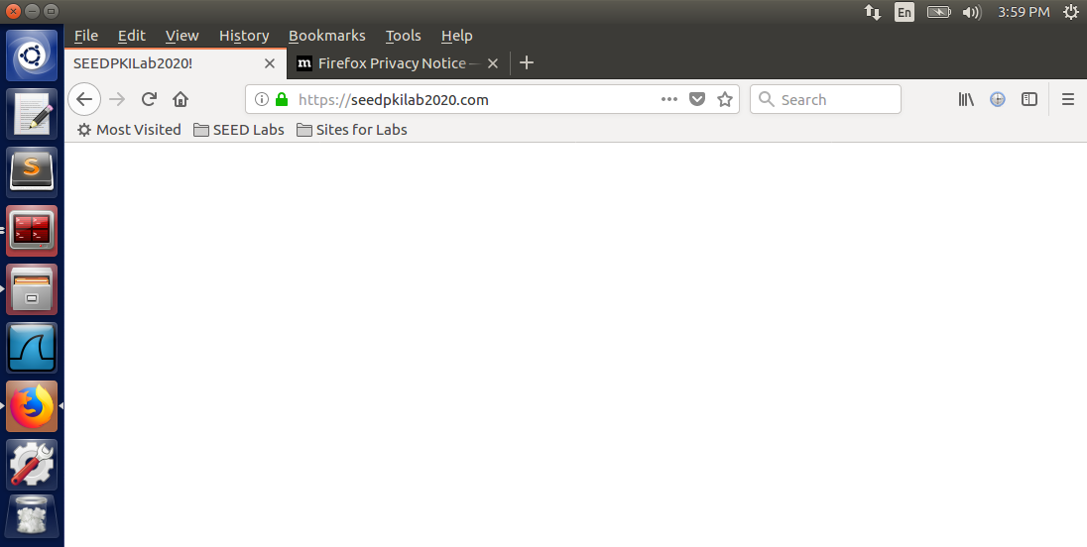

Observation: The apache2 service was used to launch the HTTPS web server. Firefox was able to connect to the SEEDPKILab2020.com server.

Explanation: Apache2 uses the sites-available/default-ssl.conf file to specify virtual hosts. The virtual host contains information relating to the web server, such as the server name, document root (location of HTML file), and the directory index (index.html). Also specified were the location of the PEM files containing the private key and certificate of the virtual host. The index.html file defines the content of the website. After restarting the apache2 service, the website was successfully launched.

Task 5: Launching a Man-In-The-Middle Attack

To launch the man-in-the-middle attack, the ServerName was edited in the /etc/apache2/sites-available/default-ssl.conf file.

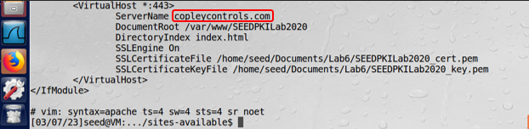

The victim’s /etc/hosts file was then edited so that the new malicious web server was included in the IPv6 capable hosts section. The IP address matched the IP address of the attacker VM so that any traffic to the copleycontrols.com domain would be redirected to the attacker by the victim’s local DNS server.

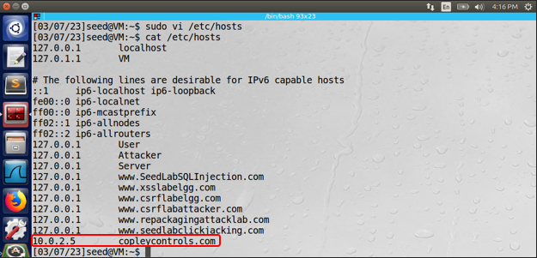

The apache2 service was then restarted using the “sudo service apache2 restart” command. The victim then attempted to access https://copleycontrols.com using the Firefox browser. The results are shown below.

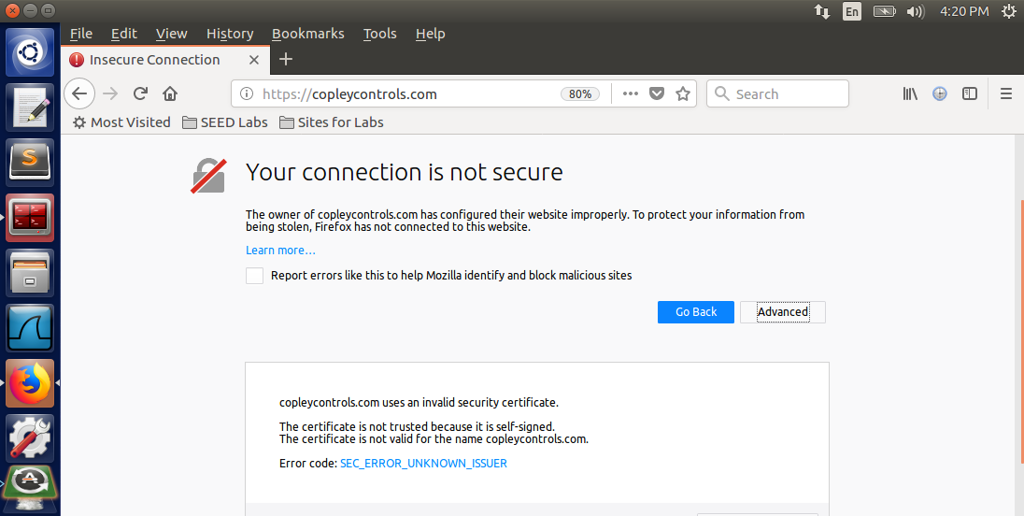

Observation: The Firefox browser would not allow the victim to access the web server because “copleycontrols.com uses an invalid security certificate. The certificate is not trusted because it is self-signed. The certificate is not valid for the name copleycontrols.com.”

Explanation: The certificate was not valid for the name copleycontrols.com because the certificate was written for the SEEDPKILab2020.com domain name (Common Domain). The copleycontrols.com domain did not match the common domain in the certificate in SEEDPKILab2020_cert.pem.

Task 6: Launching a Man-In-The-Middle Attack with a Compromised CA

The private key of the root CA was compromised, so the attacker generated a new public/private key pair for the malicious webserver “copleycontrols.com” using the following command.

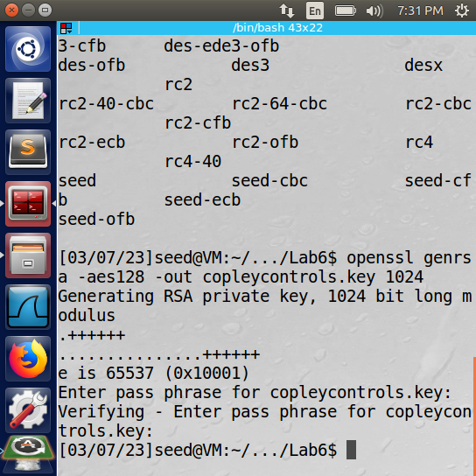

The new certificate signing request was created using “openssl req -new -key copleycontrols.key -out copleycontrols.csr -config openssl.cnf”. The information for the request is below.

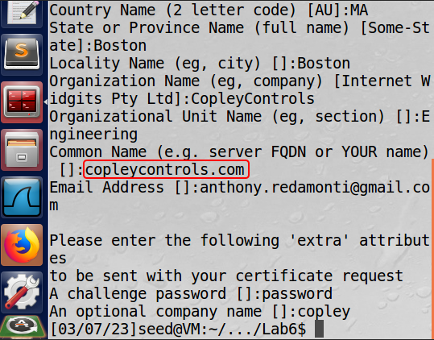

Note that the Common Name is copleycontrols.com.

The following command was then used to generate the new certificate for copleycontrols.com using the compromised private key of the certificate authority.

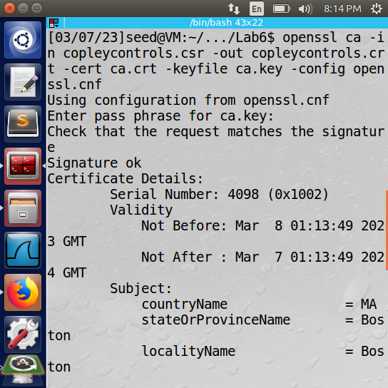

The original SEEDPKILab2020_cert.pem and SEEDPKILab2020_key.pem files were overwritten with the newly created copleycontrols.crt and copleycontrols.key files, and the apache2 service was restarted.

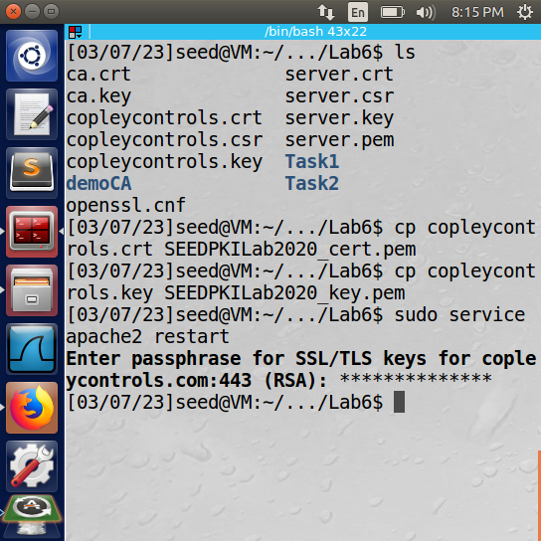

The victim then attempted to access the https://copleycontrols.com website and was successfully redirected to the attacker’s malicious web server.

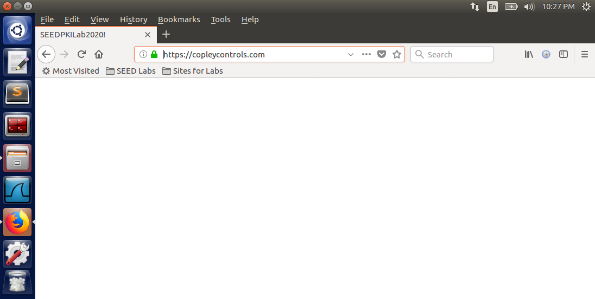

Observation: The Firefox browser allowed the victim to access the web server because copleycontrols.com used a valid security certificate. The certificate was generated using the compromised private key of the root CA.

Explanation: The following error was no longer present: “*The certificate is not valid for the name copleycontrols.com.*” The certificate was valid because the certificate was written for the copleycontrols.com domain name (Common Domain). The copleycontrols.com domain matched the common domain in the certificate in SEEDPKILab2020_cert.pem. Note: in order to overcome the error, “*The certificate is not trusted because it is self-signed*,” the victim’s Firefox had to add the certificate of the root CA as a trusted authority (similar to task 3 part 3).